Please ensure that you get into good habits;

1. Write out the title and L.O. in your exercise book. Include the date in Spanish.
2. I will be **available** to go through the work with you, but you can always use the chat option to ask me questions about any work.
3. There’s extension work, please do it if you finish the activities.
4. Submit your HW by either by sending it as an attachment or take a picture of your work and send it via TEAMS

Fecha: Hoy es lunes 23 de marzo

General conversation questions

L.O. Learning how to improve your answers

**Task 1.**Quick retrieval from previous learning

Speak aloud, can you …say the following questions words in Spanish?

|  |  |  |
| --- | --- | --- |
| ¿Cómo? | ¿Con quién/ quiénes? | ¿A qué hora? |
| ¿Para quién/quiénes? | ¿Dónde exactamente? | ¿Qué tipo de.....? |
| ¿Cuánto tiempo? | ¿Cuánto?/ ¿cuánta? | ¿Cuántos/ cuántas? |
| ¿Cuándo? | ¿Por qué? | ¿Para qué? |

Extension: Do you know what they mean? Type your answers in the Chat

**Task 2.** Look at the following tips on improving your writing

Potato Prompts Use these in all work for top marks MC900331282[1]

|  |  |
| --- | --- |
| **P** | orque – give justifications and reasons for your opinions |
| **O** | pinion positive – say what you like |
| **T** | enses – include at least 3 tenses – past, present, future |
| **A** | * material – make sure you include advanced structures, tense, phrases, grammar and vocab to aim for the highest marks |
| **T** | ime phrases – these are useful and show advanced vocab |
| **O** | pinion negative – don’t just say what you like, say what you don’t like to add variety |

**Expanding your sentences**

* **Time phrase** e.g. me levanto a las 7. Temprano – early

Tarde – late

Por la mañana/tarde/noche – in the morning/afternoon/night

↓

* **Adverb** e.g. me levanto rápidamente.

↓

* **Say why** e.g. me levanto rápidamente porque tengo una clase.

↓

* **Add a connector** and connect two phrases e.g. me levanto y después me ducho.

↓

* **Opinion** – No me gusta levantarme a las 7 porque en mi opinión es demasiado temprano.

↓

* *Add a **past tense** e.g. normalmente me levanto a las 7 pero ayer me levanté a las 7:15.

↓

* *Add a **future tense** e.g. mañana me gustaría levantarme a las 10.

↓

* \*\***Say what you do upon doing something else** e.g. al levantarme, escucho la radio – upon waking up I listen to the radio,

↓

* **Add an **advanced structure** e.g. después de haberme levantado – after having gotten myself up

Expand this sentence: “**voy a un festival**” by adding more information step-by-step

* **Time phrase**

**_____________________________________________________________________**

↓

* **Adverb _____________________________________________________________**

↓

* **Say why** _____________________________________________________________

↓

* **Add a connector** and connect two phrases _______________________________________________________________________

↓

* **Opinion** – _______________________________________________________________

↓

* *Add a **past tense** ________________________________________________________________________

↓

* *Add a **future tense**

________________________________________________________________________

↓

* \*\***Say what you do upon doing something else**

________________________________________________________________________

↓

* **Add an **advanced structure** ________________________________________________________________________

**Task 3** Record yourself reading your sentences aloud using the microphone on Teams. Send them to me to listen, try reading them with your best pronunciation. Merits for the best pronunciation

**Task 4** Write out 3 sentences: Send me a picture of your work via Teams Consider the time phrase (El verano pasado, etc) and write out the sentence in full, conjugating the verb correctly in the correct tense by interpreting the action in the picture. You can also add further information to develop the sentence (*e.g.who with, where, why, opinion, etc*.) Translate each sentence into English, carefully considering how you would say it in English.

Example

La semana pasada (I) 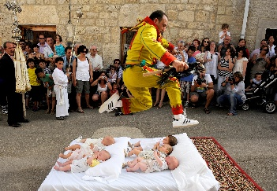 .

La semana pasada fui a ver el Colacho. Me gustó porque fue muy emocionante. Last week I went to see the Colacho festival. I liked it because it was very exciting.

1. El año pasado (we) 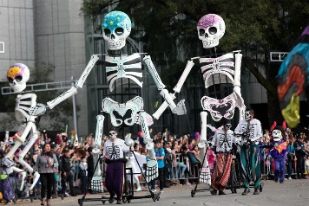 

2. Hace dos meses (I) 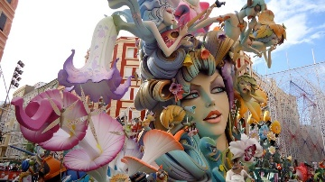 

3. Ayer (they)  

SMHW: Type your answers from your yellow booklet

Submit by Wednesday 25.03.20 9.00am